PROPOSED SCHEME

RANKING OF CLOUD SERVICE PROVIDERS

USING FEEDBACK

Ranking of cloud service providers mainly used for the customers choose the best provider upon several service providers. It is difficult task to identify the best provider. In this ranking of cloud service provider provide the rank list of service providers based on the feedback that will be given by the several customers. Using this customer easily identify the best provider.

STEPS FOR RANKING CLOUD SERVICE PROVIDERS USING FEEDBACK:

Step1:

In first step, cloud service provider register in SLA repository.

Step2:

In this step, get the cloud provider name and service that will provided by the provider.

* Provider name
* service

Step3:

Check whether the customer wants to provide the feedback for the particular cloud provider. If yes, provide the feedback based on following

* Positive
* Negative
* Neutral

Step4:

If all customer provide the feedback for the cloud provider then calculate the percentage for particular provider.

prov[i]= ((float)pos_fb[i]/(float)tot_fb[i]) * 100

Step5:

Once the percentage will be calculated, then print the rank list based on this feedback percentage.

PROGRAM:

import java.io.*;

import java.util.Scanner;

public class FBcal

{

public static void main (String args[]) throws IOException

{

BufferedReader inpt = new BufferedReader(new InputStreamReader(System.in));

int[] pos_fb = new int[3];

int[] neu_fb = new int[3];

int[] neg_fb = new int[3];

int[] tot_fb = new int[3];

float[] prov = new float[3];

// String[] pro=new String[3];

String[] pro={"hp","amazon","ibm"};

int val;

int fb_val;

int rank;

for(int j=0;j<3;j++)

{

System.out.println("\n CUSTOMER"+(j+1));

for(int i=0;i<3;i++)

{

System.out.println("Do you want to give feedback for "+pro[i]+"\n\n Enter \n 1.yes\n 2.no");

val = Integer.parseInt(inpt.readLine());

if(val==2)

continue;

else if(val==1)

{

// obtaining feedback from customers

System.out.println("\n ******FEEDBACK VALUES****** \n");

System.out.println("1. POSITIVE\n2. NEUTRAL\n3.NEGATIVE");

fb_val = Integer.parseInt(inpt.readLine());

if(fb_val==1)

{

pos_fb[i]=pos_fb[i]+1; // Positive feedback

}

else if(fb_val==2)

{

neu_fb[i]=neu_fb[i]+1; // Neutral feedback

}

else if(fb_val==3)

{

neg_fb[i]=neg_fb[i]+1; // Negative feedback

}

}

}

}

for(int i=0;i<3;i++)

{

// calculating total feedback

tot_fb[i] = pos_fb[i]+neu_fb[i]+neg_fb[i];

System.out.println("total feed back"+tot_fb[i]);

System.out.println("\nPositive feed back"+pos_fb[i]);

}

// Feedback percentage for each provider

for(int i=0;i<3;i++)

{

prov[i]= ((float)pos_fb[i]/(float)tot_fb[i]) * 100;

}

System.out.print("FEEDBACK PERCENTAGE");

for (int i = 0; i < 3 - 1;i++)

{

System.out.print("\n"+ pro[i] + " :"+ prov[i]);

}

System.out.print("\n"+pro[3-1] +":"+ prov[3-1]);

System.out.println("\n!!!!!! DO YOU WANT TO SELECT PROVIDER BASED ON FEEDBACK RATING !!!!!!\n\n ENTER \n1. YES\n2. NO");

rank = Integer.parseInt(inpt.readLine());

if(rank==1)

{

float temp;

String temp1;

for (int i = 0; i < 3; i++)

{

for (int j = i + 1; j < 3; j++)

{

if (prov[i] < prov[j])

{

temp = prov[i];

prov[i] = prov[j];

prov[j] = temp;

temp1 = pro[i];

pro[i] = pro[j];

pro[j] = temp1;

}

}

}

System.out.print("FEEDBACK PERCENTAGE");

for (int i = 0; i < 3 - 1;i++)

{

System.out.print("\n"+ pro[i] + " :"+ prov[i]);

}

System.out.print("\n"+pro[3-1] +":"+ prov[3-1]);

}

else

{

System.out.println("\nTHANK YOU");

}

}

}

OUTPUT:

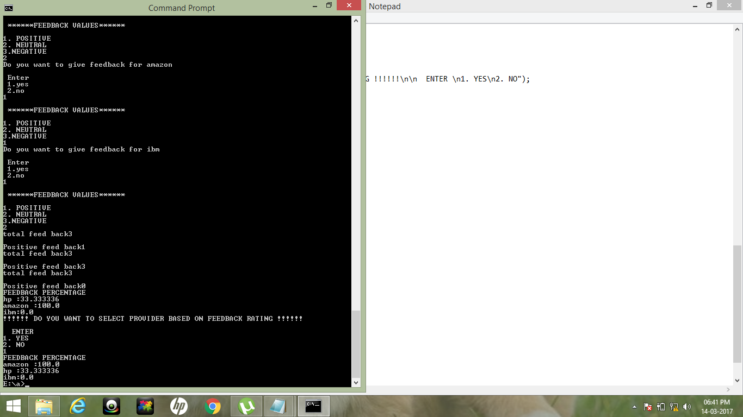

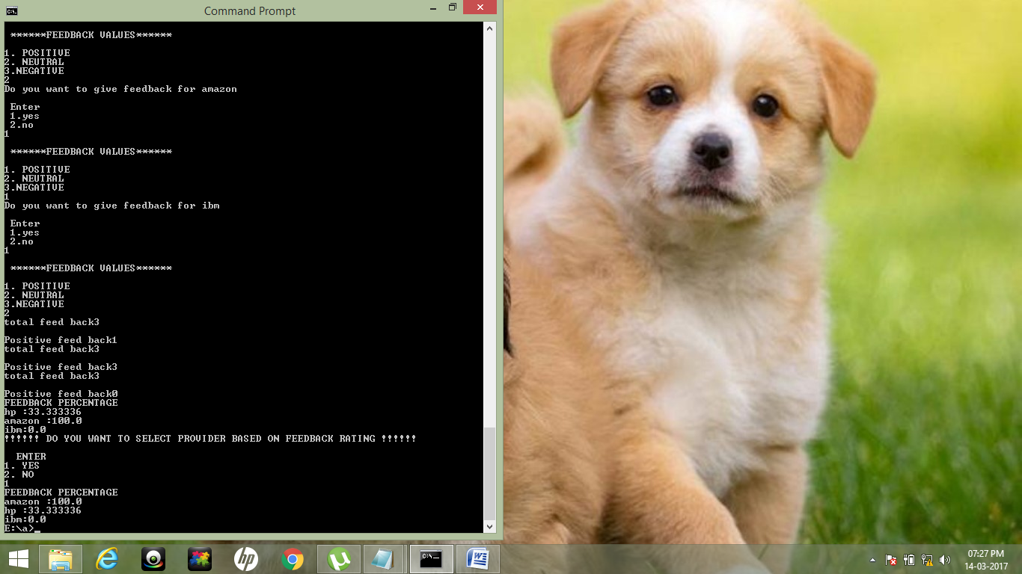

GRAPH:

OVERALL FEEDBACK